Contents
Technical Documentation 2
1 Introduction 2
2 Physical Schema 2
3 Database Development 3
3.1 Database Overview 3
3.2 Security 6
3.3 User Interface 8
3.3.1 Flowchart and Data Movement Diagrams 8
3.3.2 Interfaces Development 10
4 Maintenance 12
4.1 Database recovery & backups 12
4.2 Database maintenance in general 14
5 Testing 15
5.1 Data Validation 15
5.2 Output Validation 19
5.3 Security Validation 22
5.4 GUI Validation 24
5.5 Assess whether meaningful data has been extracted 26
5.6 Assess the effectiveness of testing 28
6 Evaluation of database solution 29
6.1 Effectiveness of the database solution based on user and system requirement 29
6.2 Suggested improvements 30
6.3 Evaluation based on improvements needed 31
7 Reference 32

Technical Documentation

Introduction
This document serves as a guide describing the election system I have developed. The system includes elements such as clubs, candidates, voters, and teachers who will mentor the candidates. The database includes different relationships, such as one-to-many, and many-to-many. This documentation will show how the system is effective, organized, and reliable. The system also maintains data security, integrity, availability, and confidentiality.
Technical documents are used as a manual for developers, and end-user. It will include important details of database queries, views, procedures, security, maintenance tasks, and backups detailing their purposes and functions.

Physical Schema

Database Development

Database Overview
Table | Name | Description
 | Candidates | This table stores all the needed data about each candidate:  ID int not null , unique  Fname varchar(25), not null  Lname varchar (25), not null  PK: ID since it uniquely identifies the candidates in the relation  FK: club_id, since the candidates are also enrolled in the club. So the FK is used to determine in which club is the candidate enrolled in
 | Voters | This table stores all the needed data about each voter:  ID int, not null  Fname varchar(25), not null  Lname varchar (25), not null  PK: voters_id is considered as a PK since it uniquely identifies the voter  FK: the club_id is the FK since it references another table, and since the voters are enrolled in a club.
 | Teachers | Each teacher has an:  ID int, not null  Fname varchar(25), not null  Lname varchar (25), not null  ROLE varchar940), null  PK: ID since it uniquely identifies the tuple in the relation  FK: club_id, since the teachers are also enrolled in the club. The teacher is identified according to what club he/she is enrolled in.
 | Clubs | This table represents many clubs that candidates, voters, and teachers can enroll in. It includes all the details need:  ID int, not null  Fname varchar(25), not null  Lname varchar (25), not null  PK: ID since it uniquely identifies the tuple in the relation  FK: club_id, since the candidates are also enrolled in the club.  Name varchar(30), not null  PK: ID since each club is uniquely identified by its ID
 | Votes | This table was the result of mapping since we had a M:M relationship between the voters and the candidates. It includes the attributes (candidates_id, teachers_id) they are both PK and FK since the votes depend on those ids but they are considered FK because they reference another table.
 | Mentors | This table was the result of mapping since we had a M:M relationship between the teachers and the candidates with the relationship (mentor). It includes the attributes (teachers_id, candidates_id) they both are FK and PK since they are taken from other tables, and they are primary keys because the ID is used to identify which teachers’ mentor which candidates
 | Club_address | This table stores the addresses of the clubs. Address is an attribute that can be multi-valued this is why a new relation was created with the PK (id, and address). ID in this table is also a foreign key since it references another table.
 | Club_phone | This table stores all the needed data about each club:  ID int, not null. ID is a FK and an PK since it is taken from another table and reference the club_phone but it uniquely identifies the candidates  Phone_number varchar (15) ,not null. This will also be a primary key of this table since it uniquely identifies the club by its phone numbers
 | Candidates_phone | This table stores all the needed data about each candidate:  ID int, not null. ID is a FK and an PK since it is taken from another table and it reference the candidates_phone but it uniquely identifies the candidates  Phone_number varchar (15) ,not null. This will also be a primary key of this table since it uniquely identifies the candidates by its phone numbers

View | Name | Description
 | Teacher_view | This view will show the teacher's name, candidates’ names, and the club they enrolled in
 | Candidates_voters_view | This view will show the candidates and who voted for them
 | Club_teacher_view | This will show the teachers’ ID, fname, lanme, and the name of the club they are enrolled in
 | Candidates_club_view | This view is to show the id, fname, and lname of the candidates in which club (name) they are in
 | Total_votes_view | This view will show the number of votes each candidate received

Procedure | Name | Description
 | selectAll | It will help show all the records of the tables in the database since I included all the select * from in the procedure body.
 | Getthevotes | This procedure uses a group by to show the total number of votes each candidate receive.
 | candidatesinclubs | This procedure shows the candidates ID and the club_id they are enrolled in
 | delcandidates_phone | This is a procedure that deletes the phone number of a candidate from the candidates_phone. It deletes the phone number of the entered candidate_ID

Security
User name | Privilege Command | Description | Screenshot
Teacher | grant all on candidates to teachers | This command gives all the teachers all the privilege to see the candidates’ tables | 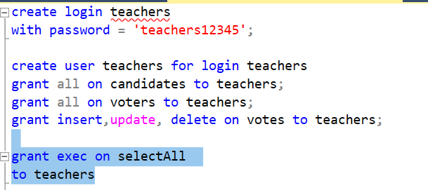
 | grant update on votes to teachers; | This command gives the teacher the privilege to update the votes tables, who voted to who.
 | grant all on voters to teachers; | This command gives all the teacher all the privileges to see the voters tables (id, fname, and lname)
 | Grant exec on selectAll to teachers | The teachers can use the procedure (selectAll) to view all the records
Candidates | grant select on candidates to candidates | this command gives  the privileges to view the records of the table | 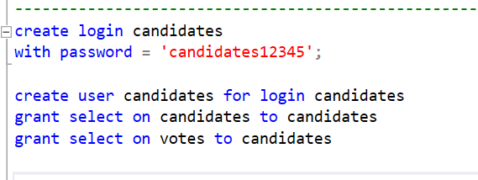
 | grant select on votes to candidates | this command gives  the privileges to view the records of the votes table
Voters | grant select,update on voters to voters | This command will allow the voter to select and update the voters' table | 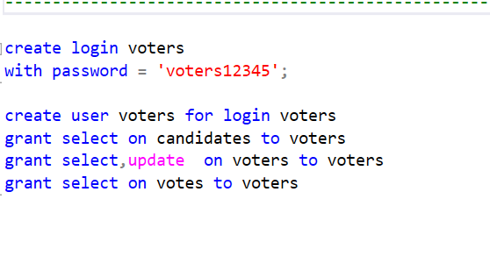
 | grant select on votes to voters | This command will only allow the voter to view the records in the vote’s tables
 | grant select on candidates to voters | This command will allow the voters to view the records from the candidate table

User Interface

Flowchart and Data Movement Diagrams

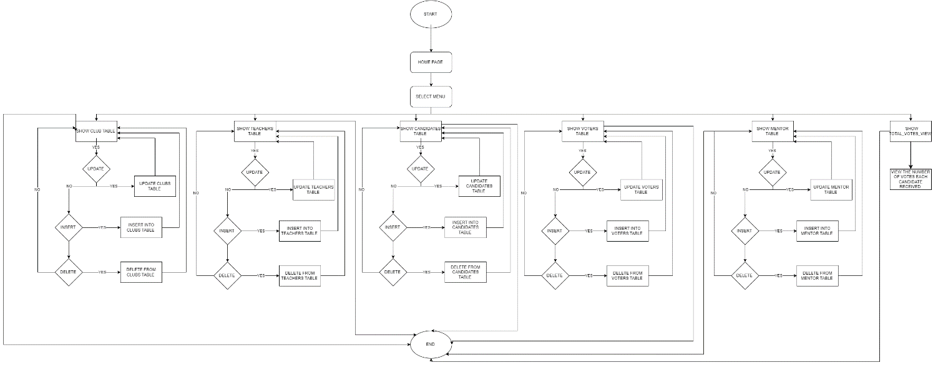
User: voters
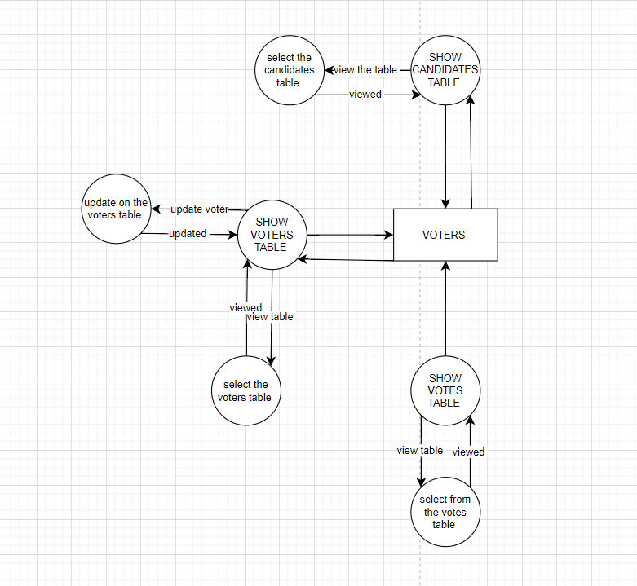

User: teacher
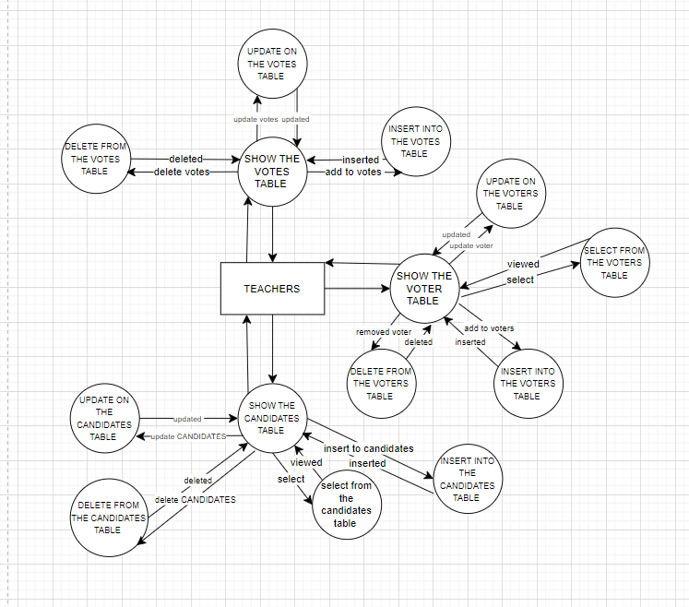
User: candidates
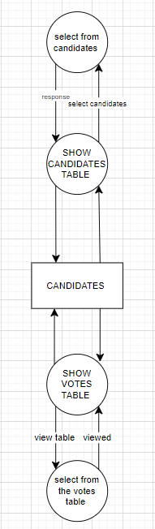

Interfaces Development

The screenshot included will show the teacher (user), and the actions it will perform on every table the user was granted access to.
Page ID | Title | Description | Screenshot
 | Candidates | The teacher (user) can update on the candidates table; I updated the ID of the candidate ‘Rania’ | 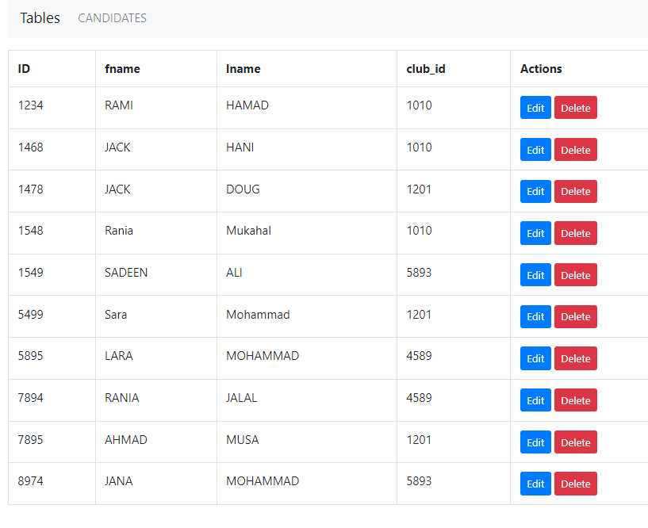
 | Voters | The user ‘teachers’ can delete records from the voter's table | 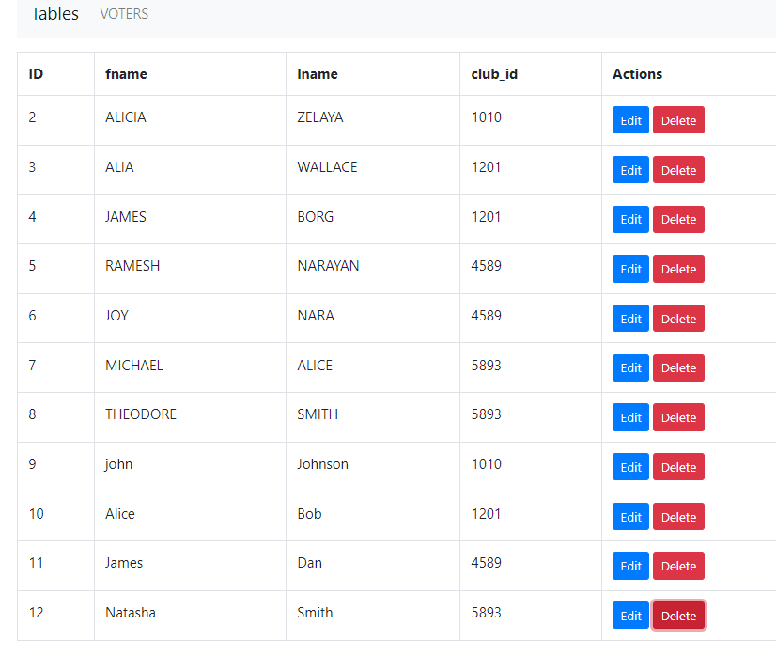  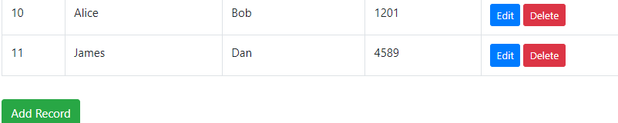
 | Home page | These are the tables the teachers can perform on. | 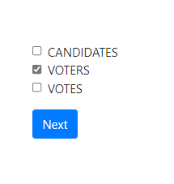
 | Votes | This table shows who from the voters voted to which candidate | 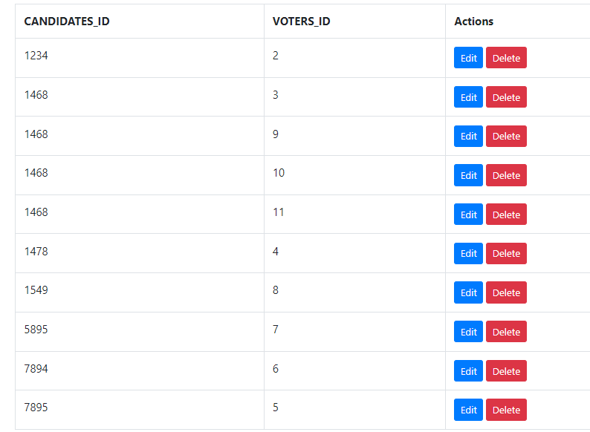
 | Voters | This table shows that the teachers can add or insert voters into the voters table | 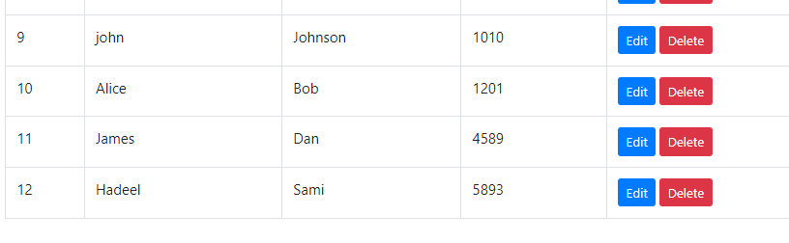

Maintenance

Database recovery & backups

Database recovery and backups are important to the data management strategy. Backups help maintain data integrity as they provide a reliable point to be able to recover the data if any issue takes place, it also protects the data in case of any data loss.
Backup is an image of the database during full backup; when you back up the database you are generating a new copy to another device or any device that is not the same as the SQL server perhaps that you can later restore the original database. You can never store the backup on the same device or the same SQL server because if the server went down, we would lose both the data and the backup we created in case of any disaster. Having a good recovery strategy is essential to meet the needs of the user and to make the database system more reliable. Backing up the database is a must since many unforeseen events may take place such as hardware failure, data loss, or user errors.
At first, there are some backup types such as full, differential, and transaction log backup that we might create at our database level since it doesn’t support table-level backup. To restore the database, we use full backup since it contains a copy of the entire database, but it will take a lot of time and space.
Full backup is a type of backup that will copy the will backup the entire database system, including the data, tables, views, and stored procedures. As it creates a copy from the database, it can be restored whenever it is required. Since it copies everything, it will require more time and more storage space. I created a fullback for my database and saved it in ‘-- to restore a database from a full backup and saved it at 'C:\backup\election.bak'.
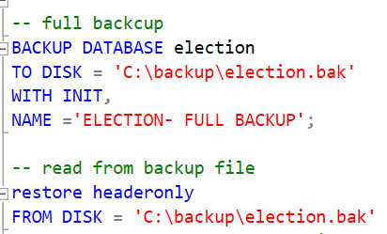
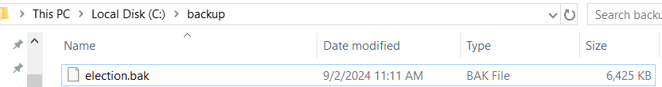

Differential backup
To create a differential backup we must have at least one full backup in the system; the differential backup will see all the changes since the last full backup.
In comparison with the full backup, the differential backup is very fast in comparison with the full backup since the differential backup captures only the data that has been altered after the last full backup. A differential backup requires less storage than a full backup, and as a result, using differential backups will decrease the risk of losing data. Ergo, the differential backup is faster and takes up less space than the full backup, but restoring a differential backup will take more time than the full backup since you are resorting to the recent full backup and the differential backup while in the full backup, you will be restoring only the full backup which will take less time. 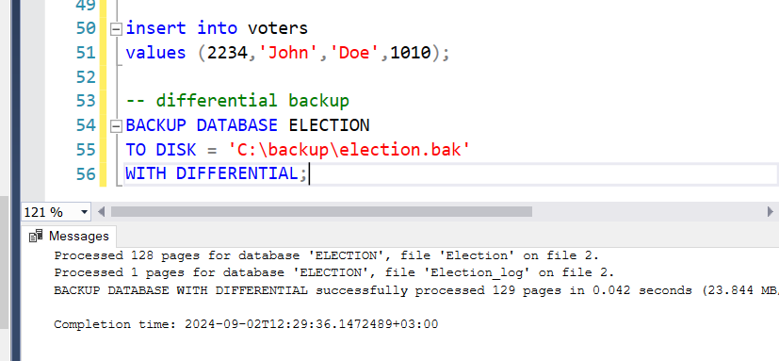
Now after the first full backup, a new voter was inserted into the voter's table and a differential backup was executed after it.
The last backup is the transaction log backup; before a transaction log backup, we have to have at least one full backup. I didn’t perform a transaction log backup since I don’t want the system to capture every transaction that occurs in the database.
I performed one full backup to capture the entire database providing a clear and complete snapshot of the system at specific points. I used the full backup with the option ‘with init’ to overwrite any previously existing backup files to make sure that the backup will contain the most recent copy of the database. Then I performed a differential backup after inserting a voter into the voter table to make sure that the voter’s information was saved and backed up. This differential backup will contain all the changes that took place since the recent full backup. Then I inserted a vote into the votes table and performed a differential backup afterward to make sure that the vote was stored, and finally performed a last full back up with the option ‘with noinit’ to make sure that the data would not be overwritten and that it will only be extended within the same file to make sure that everything was stored and backed up in the system to ensure data integrity and to prevent anything for getting lost.

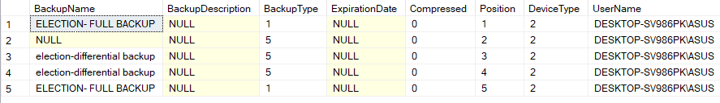

Database maintenance in general

Database maintenance refers to procedures followed to improve the database and ensure that it operates properly. Generally, it is used to organize and maintain the data created; it guarantees that the database is functioning, efficient, and secured. These checks aim to enhance performance, ensure data integrity, availability, and confidentiality, and they also check for hardware faults. Maintaining the data is essential since it ensures longevity, and the health of the database, as it prevents issues such as data corruption from taking place.
Ongoing regular checkups for database maintenance have many benefits. Keeping database maintenance is essential for organizations to stay ahead since innovations and technologies are rapidly rising and progressing so fast. Maintenance also helps improve the database and keep it efficient by deleting redundant and useless data, and it might also help generate a copy of the data in case of damage to the system or issues that might take place. Improper data management can also result in data quality problems and inconsistent data sets.
Initially, the database maintenance conducts integrity checks as the database undergoes multiple changes, such as adding, deleting, or modifying data and altering tables leading to a change in the overall schema. Each change to the data could potentially corrupt or impact the database negatively. Performance issues to the schema, data loss, or data corruption might occur. The database administrator must examine and analyze the database to detect any corruption or errors that come across it. Checkups must happen weekly to prevent data loss.
Additionally, it is essential to maintain the database for backups and recovery purposes. Regular backups ensure that data can be recovered and preserved on another backup device allowing the database restoration whenever damage occurs.
Database maintenance aids in conducting security audits to ensure that sensitive and confidential data are secured. Security checks help protect the data against malicious attackers or threats. Upgrading the database can also help keep the data up to date with the latest security protocols.
Database methods are strategies and techniques used to create, maintain, and retrieve data within a database system. These methods are essential for managing data effectively and efficiently while ensuring data availability, integrity, and confidentiality. Data normalization is the process of organizing data to reduce redundancy and improve data integrity, another method might be data security which protects the data from unauthorized access a way of keeping the data secure might be encryption. Regularly backing up data is essential to prevent data loss due to unforeseen events, hardware failure, or data errors. Installing a monitor to look for damages might also be a good precaution to stay alert in case of any damages or accidents that might take place.
Ultimately, data maintenance is important to keep the data integral, confidential, and available whenever the data is required. It is also essential to ensure that the data is backed up and updated to prevent any damage that might occur to the data. Keeping the data organized and cleaned to reduce any redundant and unwanted data.

Testing

Data Validation
Number | Type | Description | screenshot
 | All cases of PK | Uniqueness in the ‘CLUBS’ table to ensure that the ID of the club is unique | 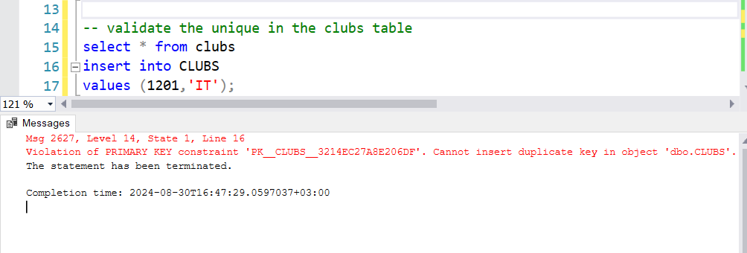
 |  | Nullability on the clubs table means you cannot insert a null value CLUBS_ID. | 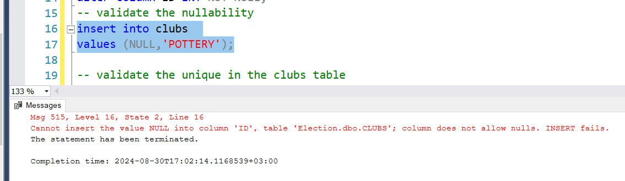
 | All cases of FK | Referential integrity since I inserted a statement into the candidate table with a club_id that doesn’t exist into the foreign key in the candidate’s table. | 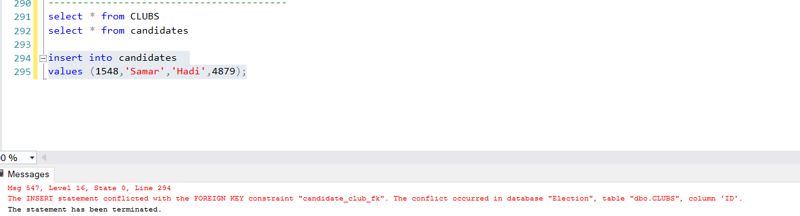
 |  | On update cascade on the FK in the mentor's table and specifically, the FK (mentor_candidates_fk), so that when anything is updated from the candidate's table on the PK (candidates_id) it will also be updated on the mentors' tale on the FK | 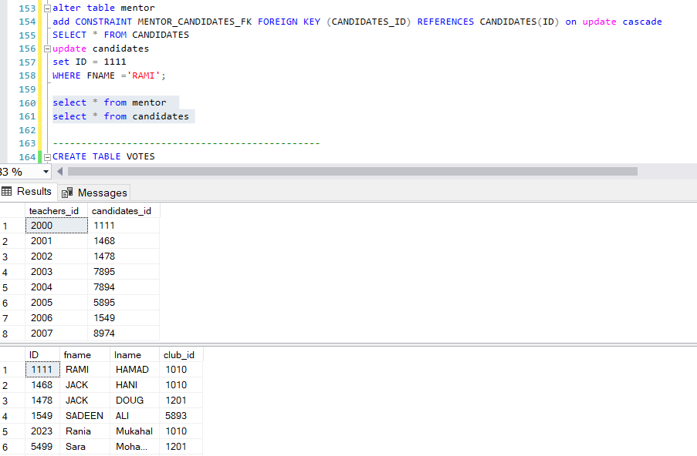  Before:  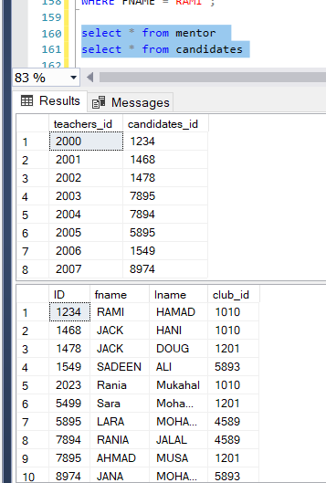
 |  | Delete cascade is applied on the votes_voters_fk in the votes table. If a row in the voter table was delete ( like in the case shown in the screenshots where the voter with the ID=1 ) the voter will automatically be deleted from the votes table | Before:  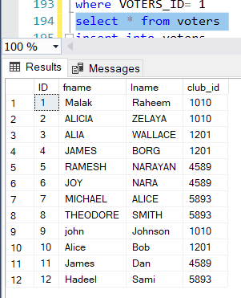  After:  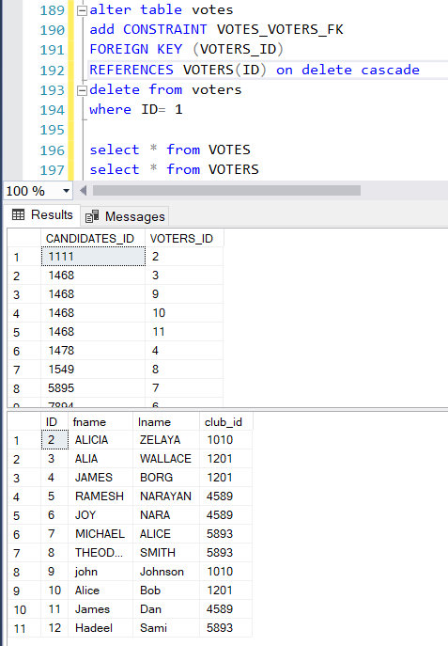
 |  | On delete no action | 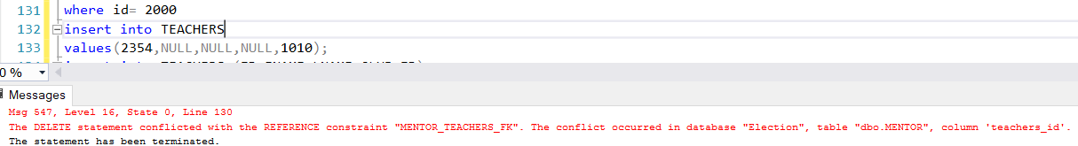
 | Unique | In the ‘CLUBS’ table the PK is unique, so the ID of the clubs must be  unique and not  repeat | 
 | Default | Automatically inserts teacher role as substitution, not to repeat the values for roles when. | 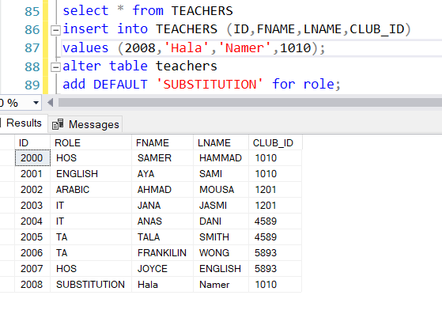
 | Not null | The fname, and lname are both set ‘NOT NULL’ they must be both filled with information and they can’t be kept empty | 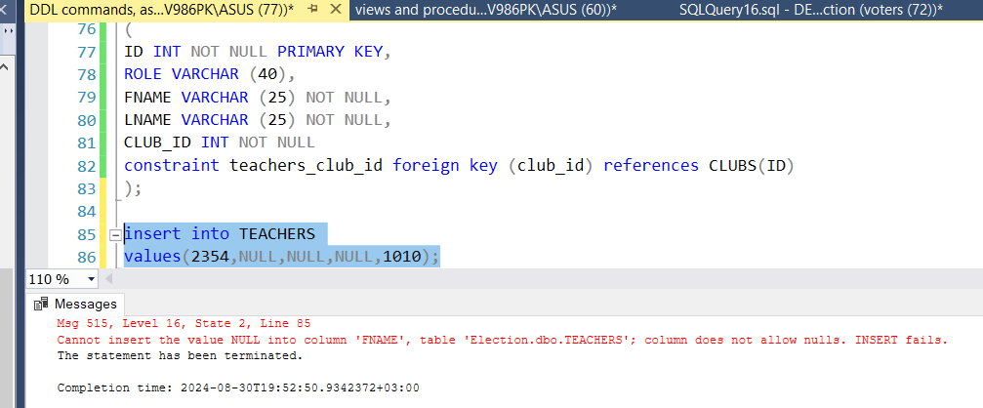
 | Check | This command is used to check something, in my case I added the check to the club’s tables to ensure that no more clubs are added except the ones entered. | 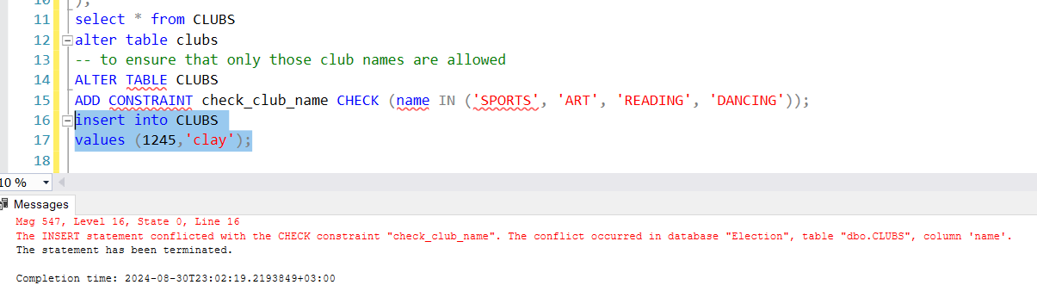
 | Values | The data type has to be the same. The second examples talks about the size, when there are a lot of values or digits there will be an overflow. | 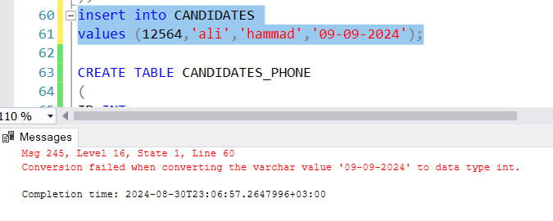  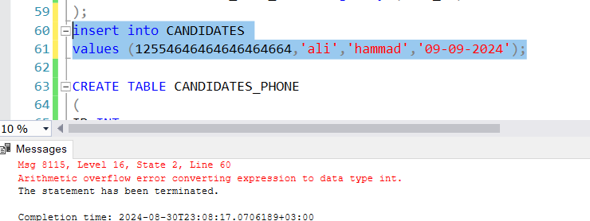

Output Validation

Number | Query Description | Screenshot (query + result) | Result validation
 | This query is used to find the candidates enrolled in the club with the ID ‘1010’. And the result validation shows ‘select *from candidates’ | 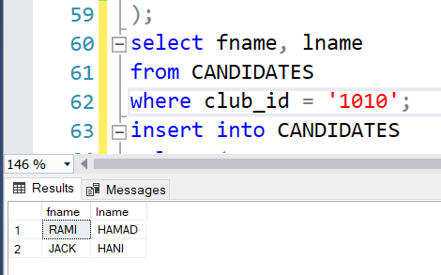 | 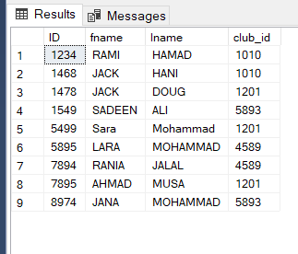
 | This join shows the voters and the candidates fname, and lname that belong to the same club; based on the clubs’ IDs they share. | 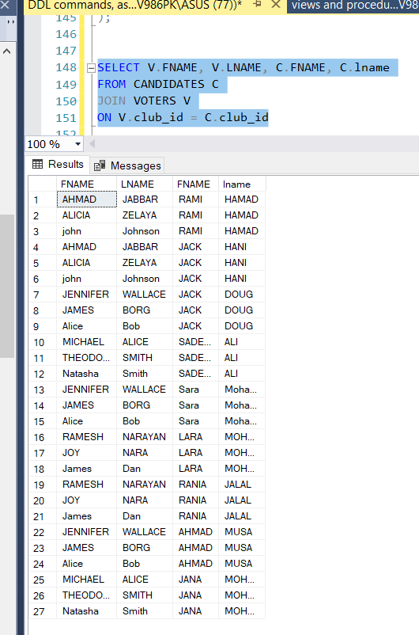 | 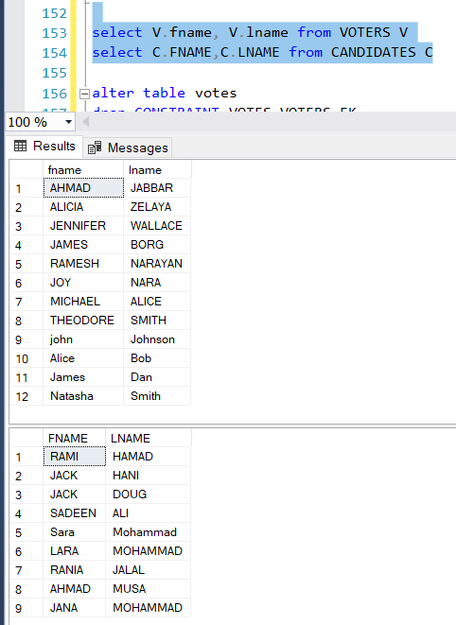
 | Insert statement here is for the voters table; it adds the id, fname, lname, and the club_id to this table. And I used the delete command to delete the voter with ID = 1, and it was deleted as shown in the results below. | 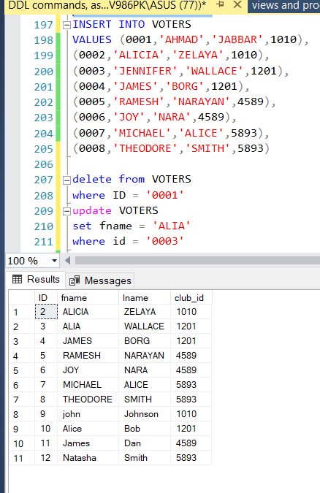 | 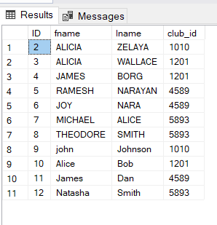
 | The update command will update the voter with the id=3 and update the fname to Alia | 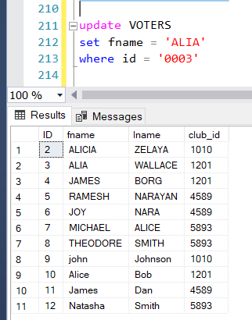 | 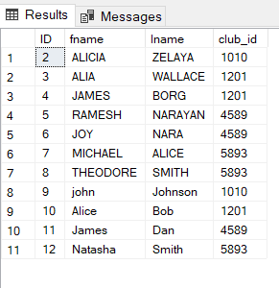
 | This group by counts the number of votes the candidates received. | 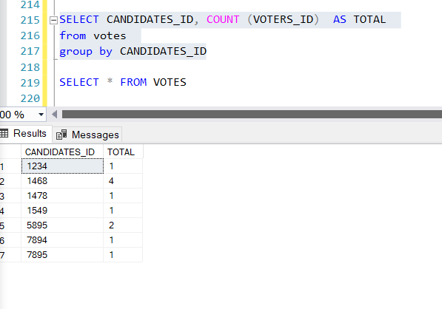 | 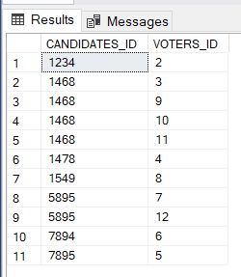

Security Validation
Note: you need to test the given and not given privileges.
Number | User Name | Description of privilege/no privilege | Screenshot (query + result)
 | Teachers | Teachers are granted all the privileges to the voters and candidates. The are given the privileges to insert, update, and delete the votes.  In these commands the teacher (user) was able to select from the voters, votes, and candidates tables. and I also tried to show an example of the teachers inserting into both votes and voters. | 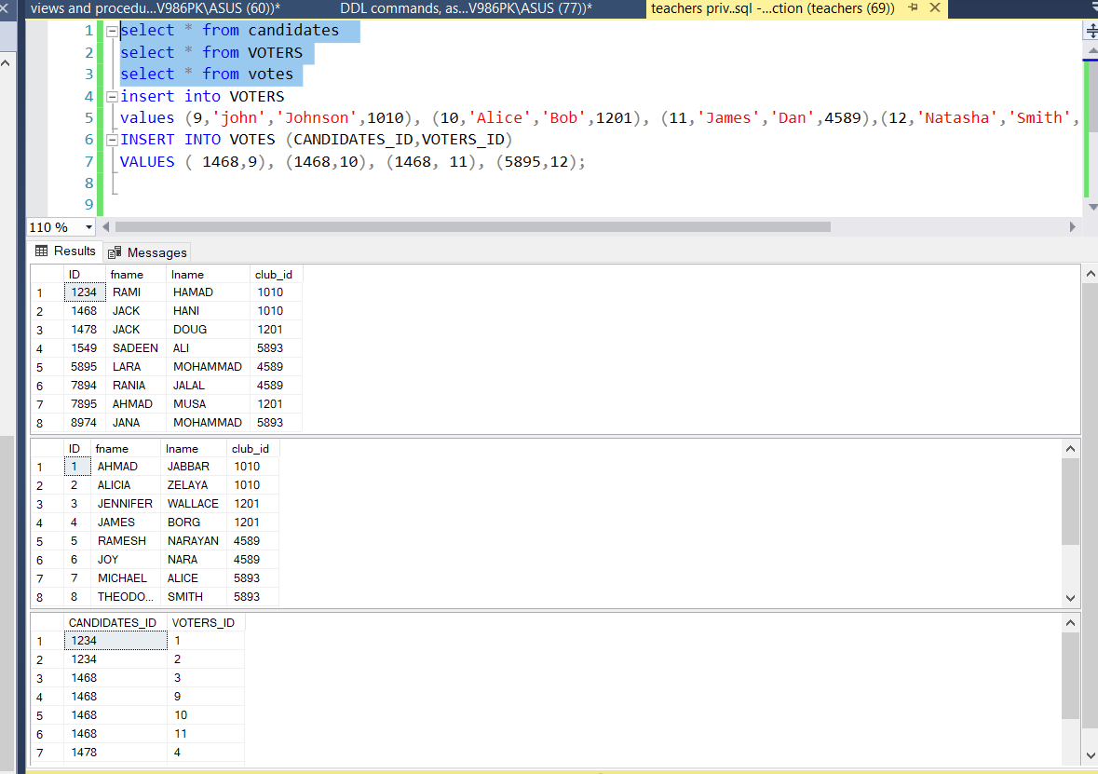
 | Candidates | Candidates have no privileges to add, insert, update or delete. They can only select from the candidates and the votes table.  In this command the select statements worked on the candidates and the votes. But the insert didn’t work since they weren’t granted the privileges to do so. | 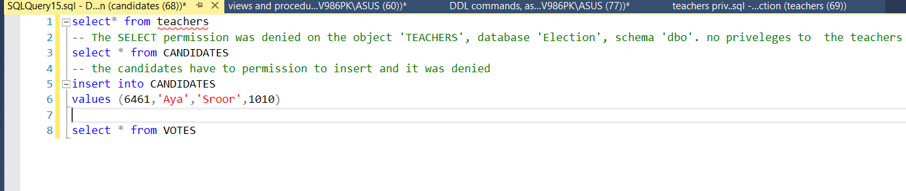
 | Voters | Voters have the  privileges to select from  candidates, votes, and  voters. They can also  update on the voters.  The command “select * from teacher” will be  denied since they were  not granted these  privileges. The insert into candidates will also be denied since they don’t have the privileges to insert into the candidate's table. | 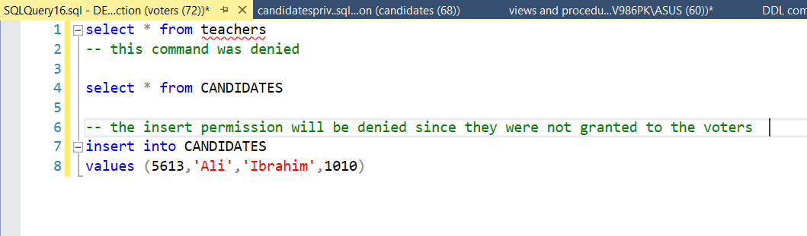

GUI Validation

Number | Description | screenshot
 | Delete was denied on the voters' table from the candidate's user. | 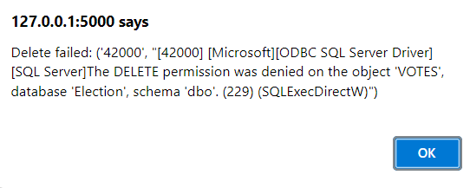
 | The teachers can insert into the candidate's table since they were granted that privilege. | 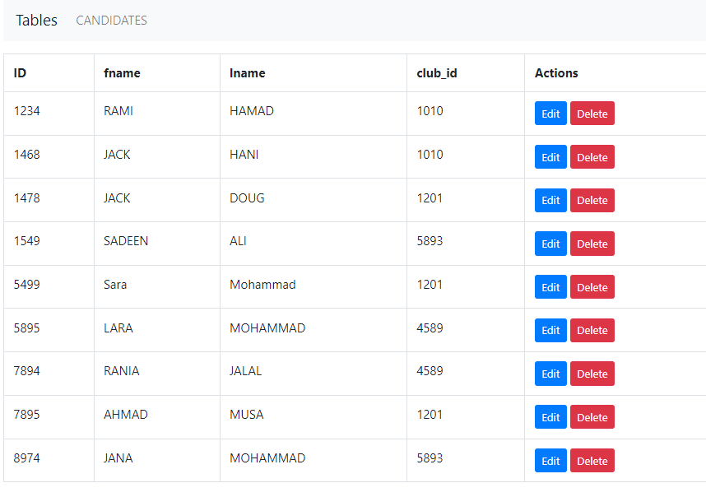  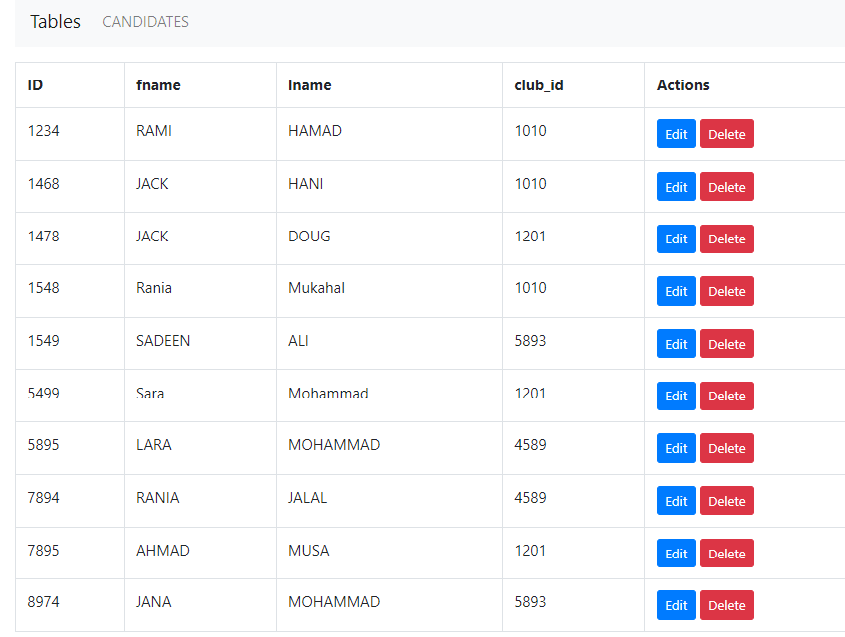
 | An update on the candidate's table was denied from the candidate’s account/user. | 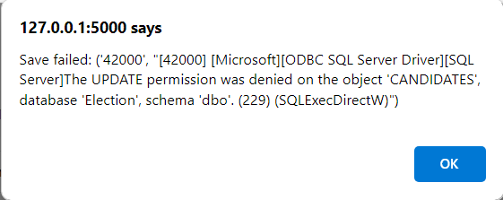
 | Select; candidates can view the candidates table from their user, but cannot edit, or delete any information. | 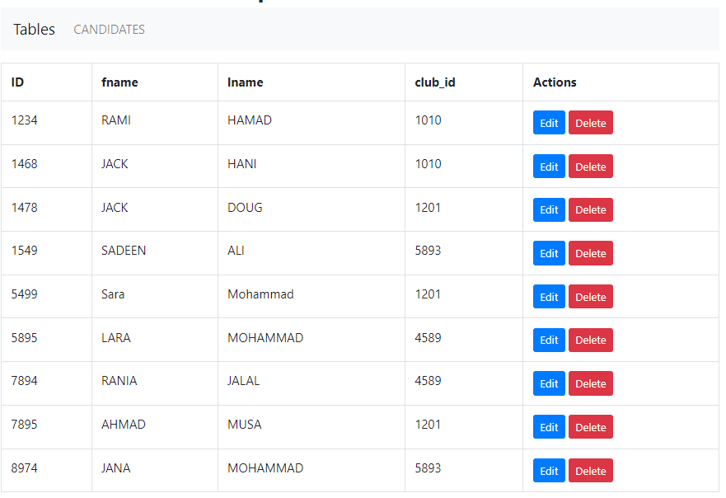

Assess whether meaningful data has been extracted

This election system has been designed with entities such as clubs, candidates, voters, and teachers. It shows the relationship between them and the attributes of each entity. Multi-value attributes are included in my system such as candidates_phone or clubs_phone. The candidates and clubs may have multiple phone numbers, and each phone number connects to the candidate or club through the foreign key. Many attributes were set to not null since their data cannot be entered without for example their ID or name since they are essential to keep things organized in the database.
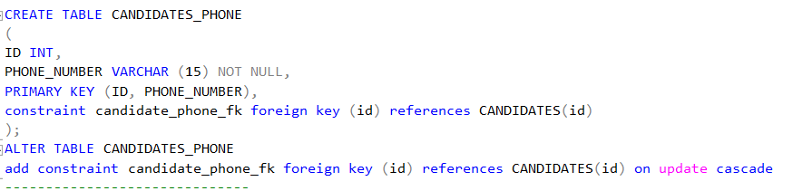
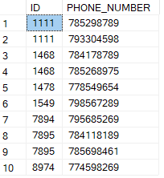
These two screenshots show that some candidates have multiple phone numbers, and in the mapping, each multi-value should be extracted into a new table.
My system includes one-to-many relationships, for example, a club has many candidates, and this is shown by the foreign key between the two tables.
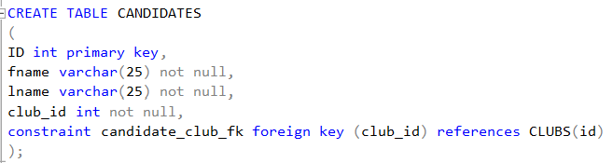
This screenshot shows the ‘club_id’ is a foreign key in the candidates' table.
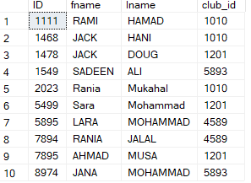
Many candidates apply to a club, for example, candidates with the id ‘1111, and 1468’ both enroll in the club (1010). Other examples of one-to-many relationships include the relationship between clubs and voters or clubs and teachers. Where each club has many candidates, teachers, and voters enrolled in it.
As for the many-to-many relationships, there is a many-to-many relationship between the candidates and voters, there is also another one between the candidates and teachers. These relations led to two new tables (votes, and mentors). Many teachers mentor many students, and many voters can vote for many candidates. Candidates can get votes from multiple voters and voters can vote for many candidates; this is represented in the votes table that connects the voters and candidates in a many-to-many relationship.
Views and procedures are essential since they provide the structure, and they also allow the admin to grant or revoke privileges from some users.
The views in my system are: teachers_view, candidates_voters_view, club_teacher_view,candidates_club_view, total_votes_view and they all have different purposes and meanings in the system.
The ‘teacher_view’ allows the teacher to see the clubs they are associated with and who are the candidates in the club. It contains a join statement that joins the teachers, clubs, and candidates’ tables together. The admin and the teachers will be able to know and view what are the clubs they are responsible for and who are the candidates that they will mentor. The ‘total_votes_view’ shows the number of votes each candidate receives. This view aims to help with counting the votes to see who the winner is.
Procedures are stored by the DBMS at the database server; it is useful since it grants and revoke permissions on a procedure, and it also protects the SQL from injection attacks. It also helps the user to reuse the code whenever it is needed. Procedures in my system include the ‘selectAll’ procedure that helps show the records of all the tables in the database at once. The ‘getthevotes’ procedure uses the group by and it shows the total number of votes each candidate gets. There are also two more procedures ‘candidatesinclubs’, and ‘delcandidates_phone’. ‘candidatesinclubs ’helps the teacher or the admin of the system see the candidate’s id in addition to their club_id to know which candidates are in which club. Finally, the delcandidates_phone helps reduce redundancy as it helps in deleting the phone number of the candidates if they no longer use it, or if it is no longer available.

Additionally, the teacher’s user will benefit from the teacher_view as it helps with managing their clubs and candidates, and it also helps with their mentoring tasks. Candidates will benefit from the candidates_voters_view as it will help them identify who voted for them. Finally, the voters’ user will be able to see the candidate's table, update and view their tables, and also view the votes table and the total views.

In conclusion, the whole system is designed to maintain data integrity, confidentiality, and availability. It provides meaningful data and efficient benefits for each user involved in the system. It also includes attributes and relationships between the tables to show how entities are connected.

Assess the effectiveness of testing

Database testing is a process that evaluates the accuracy, checks for faults in performance in the database, and checks the reliability of the database to match the business or personal needs of the client. In the election system project testing was important to check the integrity and the performance of the entire system.
Integration testing was helpful since it was used to test the relationships between the tables and the interactions between them to ensure that the one-to-many and many-to-many relationships were perfectly working out. It was also used in the system to verify that the schema, queries, procedure, views, and other components were perfectly working out. As a result, for example, the relationships between the voters and candidates or the teachers and the candidates were perfectly functioning. Every table was tested using the select, insert, update, and delete statements to check the constraints each was given. These integration tests helped me make sure that there would be no issues in any part of the database when the tables interacted with each other.

Performance testing helped me ensure that the database would keep on working under different conditions and test the responsiveness of the database. The time taken for the execution of different queries was measured by trying on different select, insert, delete, and update statements. I also evaluated the time the data takes to back up and restore the database. I also checked that the entered data matched the data type specified for each entity, the constraint given, and the relationships preventing any errors like unmatching data types, or other issues like incorrect data selection, insertion, or deletion. I made the project reliable, cost-efficient, and scalable.
I faced multiple issues while testing my database such as incorrect foreign key constraint which led to many issues that wasted a lot of my time to fix. There were errors in the logic of the query such as many incorrect join statements that produced unwanted and incorrect results.
Testing is essential since it helps submit the project with fewer errors, more security, and reliability. The process of testing helped me improve the functionality, integrity, security, and performance of the database, now the election system can manage the relationships between voters, candidates, clubs, and teachers while maintaining the data integrity as required.

Evaluation of database solution

Effectiveness of the database solution based on user and system requirement

The database was effectively implemented to meet the chosen entities’ decided upon, meeting both user and system requirements, ensuring a secure, and maintainable system for users. I will mention the user requirements of each entity and how they were implemented throughout the system:
According to the teachers’ requirements, in the development phase, a user was created for them to be able to view the tables based on the privileges and the tables they were given access to (T1). Based on the requirements (T2 & T3) the teachers were able to generate reports and view the clubs they were responsible for, the candidates they were mentoring, and the votes that each candidate got. They are granted access to the candidates, voters, and votes tables, and different privileges are given to the teachers based on the tables they are viewing.

For the candidates, this entity includes attributes, such as their name, ID, and phone number (C1). Many tables were added as a result of mapping since the phone number is a multi-value attribute, and this helped keep things organized and connected to the primary candidates' table. A user was also created to grant them the ability to view and update their information (C2). With the procedures and the views given the candidates were securely able to access and modify their details in addition to other tables such as vote to be able to view the votes that they have received (C3).
Voters were able to enter their information and vote for the candidates (V1). A user (voters) was created to give them access to the candidates, voters, and votes table. They can only view all the tables and update the voter’s table. They were also granted access to the total_votes_view to check on the total number of votes the candidates were receiving (V2 & V3).
The club requirements were met by keeping the information about the candidates and voters stored in the database and giving both entities users for them to be able to have authorized access to the necessary details (R1, R2, R3).
The database was implemented with security in mind as it is very essential to keep the data confidential, available, and integral by adding constraints, such as primary keys, foreign keys, and unique and data validation rules to prevent invalid data entities (S1, S4, S5). Updates, maintenance, backups, and consistency were considered to keep the system properly functioning and well-performing (S2& S3). Regular updates and backups were scheduled to prevent data loss and corruption, improve the performance of the system, and update the system.

Almost all the system and user requirements were met, but there are other requirements that I could have added to improve the user experience further. I was not able to encrypt the data to prevent unauthorized access and protect sensitive data. Something I also wanted to include was the feedback mechanism to let the user report issues and improvements to the system. But unfortunately, I didn’t due to lack of time and unadvanced skills. During, the implementation some new issues started rising, and this is why I had to grant new privileges to users and add more views and procedures, as they were necessary to improve the user experience and the security of the system.
However, the system meets the user and system requirements covering the objectives that need to be covered. While some improvements need to be met and added the system’s overall design and development are maintained, secured, and easy, the data is kept confidential, and backups happen regularly to prevent any data loss.

Suggested improvements

Each system can be improved into something much better. Through the design part, I have changed many relations to make the system easy and efficient to users, and to satisfy them with the overall system.
For improvement, I might have added an admin as an entity to the system to take and keep up with all the records and given this admin all the privileges to the tables, views, and stored procedures. Gender and age might have been a good idea to be added as attributes to the candidates and voters’ entity to allow only certain ages (with a check statement) to vote or run for election. My system takes the name of anyone regardless of age and gender and as long as they have an ID and enroll in a club, which I think is not that organized and professional.

I might have also made security enhancements like data encryption to encrypt sensitive data such as the personal information of the teachers, candidates, or voters to ensure that the data will remain unreachable and unreadable to unauthorized users. Enhancing the backup and upgrading strategies to be able to recover the information with no issues and to stay up to date with the developments in technologies.

With these improvements, the database can be secured, user-friendly, and more organized. The more organized the system is the easier it is for the end-users to fetch information and look for data.

Evaluation based on improvements needed

Enhancing the system with all the improvements mentioned above would improve the performance and efficiency of the whole system. By adding the admin as an entity and granting it full privileges, the system would benefit from the management of records, ensuring data integrity, organization, and professionalism. The records in the system will be maintained accurately and securely by anyone who doesn’t have authorized access to the system. Adding the attributes suggested like age and gender would help with the validation; there will be restrictions, and only qualified individuals will participate in the election process. The system would be more professional and organized by adding these attributes.
Security enhancements would protect sensitive data from unauthorized access, protecting the data and reducing the vulnerabilities of the system. It is important to improve security because there might be many attackers that want to get access to the security, reducing those vulnerabilities might increase user trust. Maintaining regular backup and recovery checks would ensure that the system will not be as vulnerable to any issues that might occur in the system such as data loss or the hardware itself and whenever any fault occurs the data will still be safe elsewhere as it will be easy to recover these data.
However, all these improvements might not be cost-efficient, and the development time will be increased. For example, adding the entity ‘admin’ into the system might increase the complexity of the system and it will require more resources and time to get this task done as other relations and tables might also get affected. Another example is data encryption as it will improve the security of the system, and the organization will have the user's trust; the encryption and decryption of data may slow down the processing of the system. The improvements in backup strategies may require a lot of storage which will increase the cost.
Those improvements would benefit the system and the user positively as they would increase the security, the system would be more organized, and the system would support the requirements better, but unfortunately, they might also have other negative consequences such as increased resources, time, and cost. Any additions to the system might require other new updates to the data, entities, and attributes already there. Adding anything to the system might make it more complex as it might take time to fix the things already there, and it will also waste money.

Reference
Database maintenance explained OfficeTools. Available at: https://www.officetools.com/knowledgebase/database-maintenance-explained/
Odogwu, C. (2022) What is database maintenance and why is it important?, MUO. Available at: https://www.makeuseof.com/what-is-database-maintenance/
Database maintenance explained OfficeTools. Available at: https://www.officetools.com/knowledgebase/database-maintenance-explained/
390 (2023) What is database maintenance and why is it important?, The Tech Edvocate. Available at: https://www.thetechedvocate.org/what-is-database-maintenance-and-why-is-it-important/

